160m Mobile Contesting by Mike VE9AA.
I have tried 160m mobile before a few times, partially inspired by this photo of W1BB’s setup back in the 1970’s:
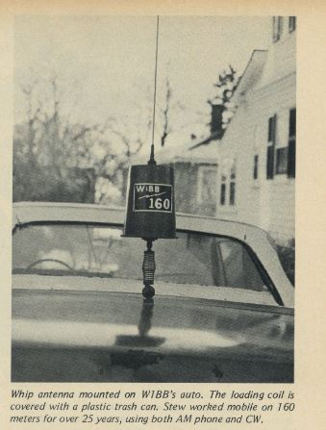 Photo from 73 Magazine.
I remember seeing this picture when I was a kid and many years later (early 1990’s) I was QRV for a brief period on 160m /M using a modified Webster BandSpanner antenna, a Yaesu FT-101E and my trusty/crusty 1980’s Ford Escort Station Wagon. I worked around 30 countries on Topband with that setup. Sadly, I can’t find any pictures of it, though I am sure I must’ve taken one. (pre digital camera era)
Fast forward the clock ~25yrs and always looking for a new challenge, I decided once again to enter the Stew Perry TopBand Distance Challenge as a mobile with my largest mobile antenna to date. I had won the category twice in the past and was going for the trifecta. To insure there was a plaque I sponsored one myself early enough that others knew this was a category and I got the word out. I exchanged many emails with a G station who was going up against me. A nice fellow, G0URR was going to gear up and give it a go! I had competition. The plaque I sponsored stated the competitors need not sign the cumbersome “/M”* so I don’t know yet if anyone else entered that category with us or not.
This year I decided I would modify my fabulous SA-680S Scorpion Antenna for 160m use and enter two Topband contests mobile with my 2009 MINI COOPER. The ARRL 160 would be the warm up & test prior to the Big Stew.
Weather being what it is here in NB conspired against me a little and just after ARRL 160, I lost both of the motors in my raise/lower mechanism on the antenna. (this is not a Scorpion product…the Scorpion antenna itself never missed a beat). I think water froze in them and when I next operated them to raise/lower the antenna, ended up chewing up all the nylon gears in their little motors.
For the ARRL 160, I had intended to put in more than an hour, but family life got in the way and I was actual mobile-in-motion for some of the QSO’s. I put in just one hour over 4 x 15min stints. Using “VE9AA/M” was a trainwreck, so hence my specs for the Stew Perry plaque*. I did hear some EU and actually worked N0NI and WA1T(in Florida) for 2 of my best QSO’s. With only 1 hour on the air and 50 Q’s I felt overly confident I’d surely make hundreds in the Stew Perry. Boy was I wrong.
I ended up only modifying the Scorpion antenna very slightly for the ARRL 160, adding 3 long wires off the Tophat and connecting them down to 3 ‘corners’ of the car with 40lb test fishing line. I enhanced the photo slightly so you can see the wires. My 15m VDA is in the background. Sadly, I lost this array just a week ago to winter ice and tremendous wind up here on the ridge.
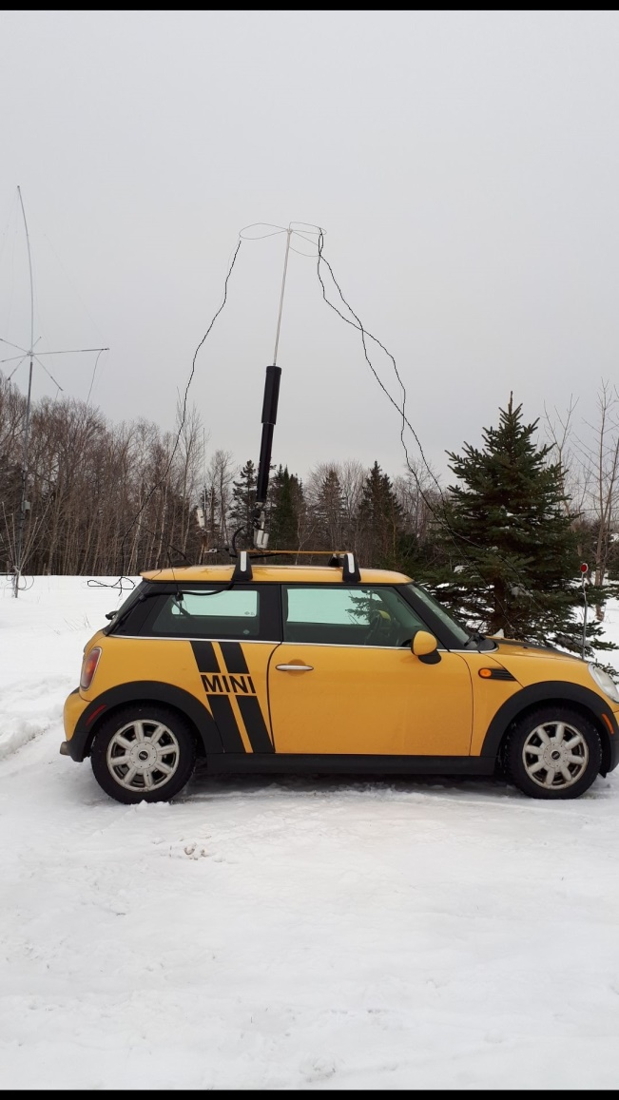
For the Stew Perry I thought I would up my game and make the main shaft of the vertical electrically fatter and add even more toploading wires. The original pic is hard to see all the wires, but I took an older (summer) photo and used Windows paint to simulate what I did. *note the antenna lean…I installed only 1 replacement motor to raise/lower the antenna and it was not an exact fit, hence the angle.
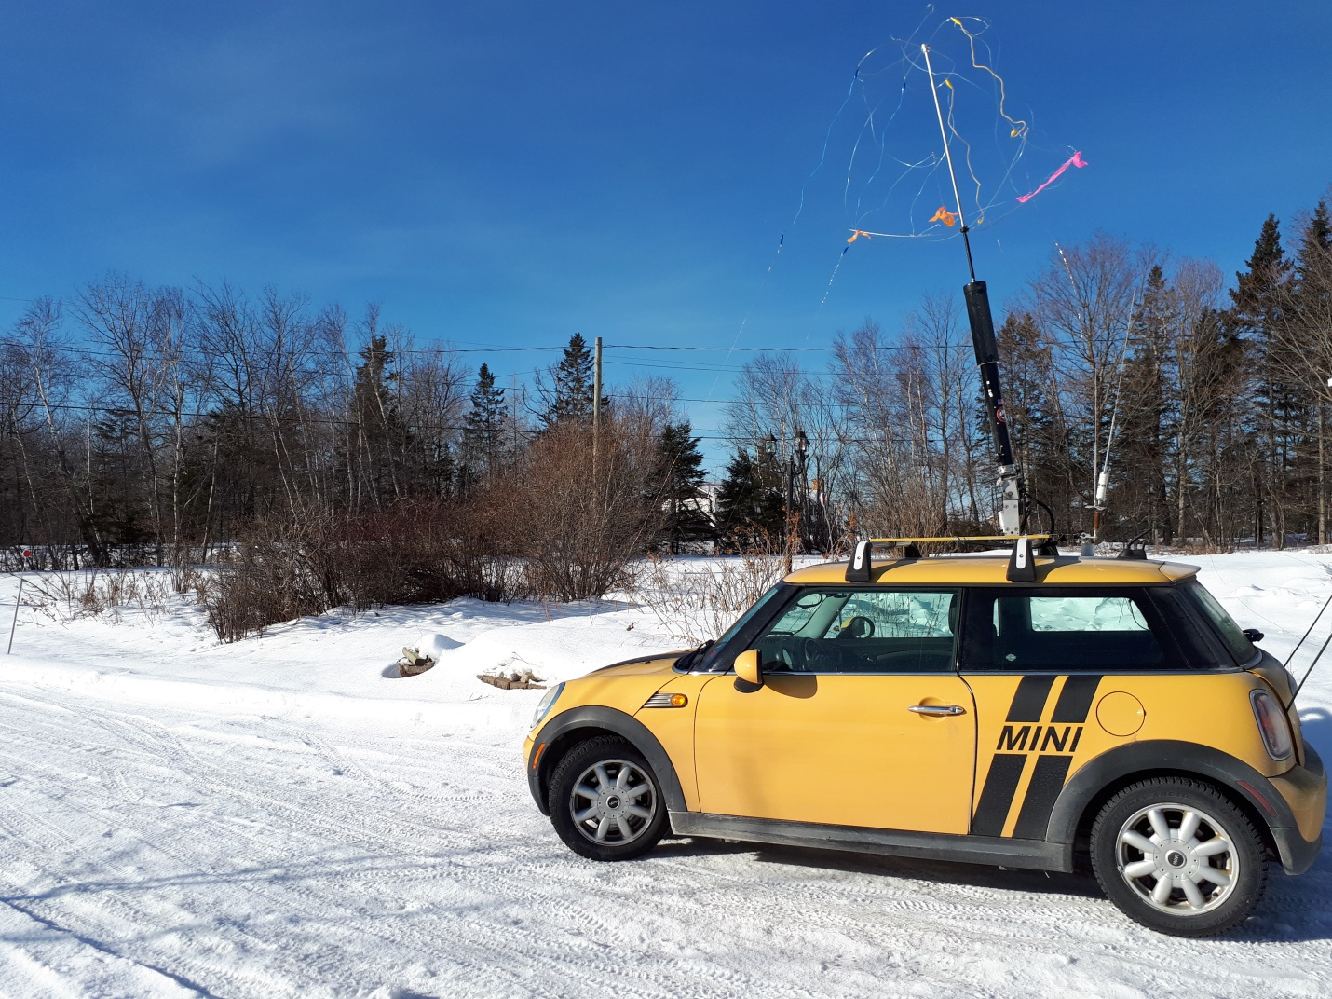
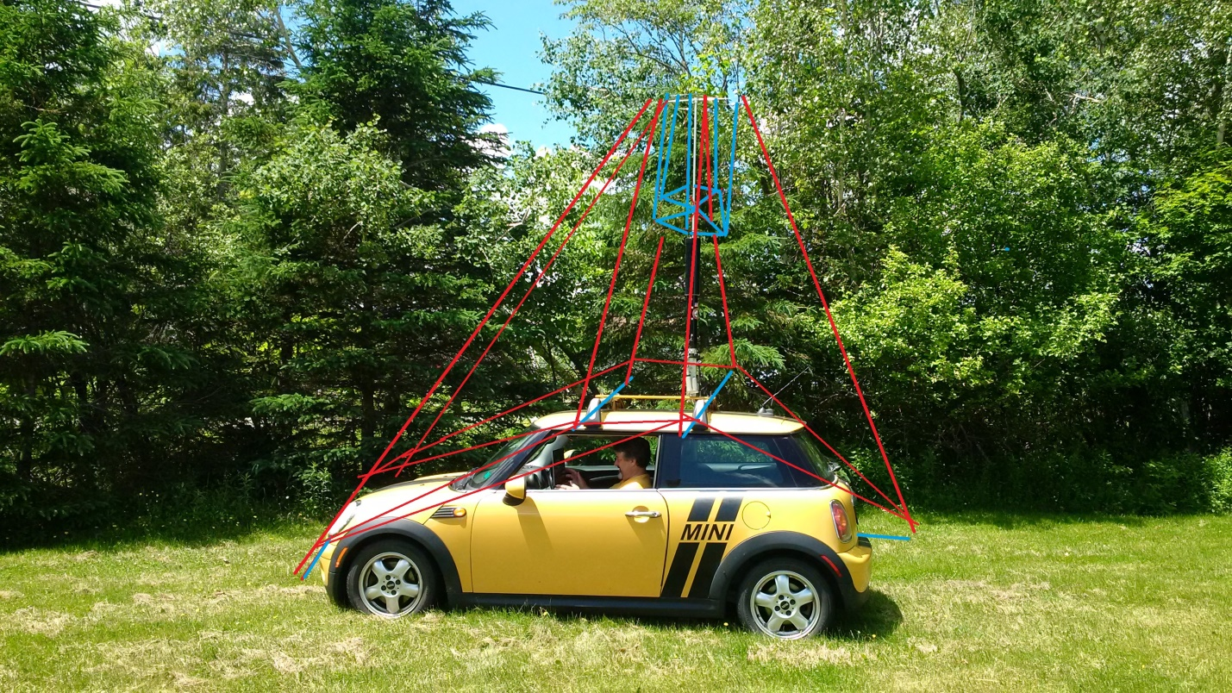
The weather turned very cold just before the big Stew, and I couldn’t drive to/from work every day like this (easily, anyways, but I did drive it 10kms to the gas station and back to meet the req’s of the plaque), so I chose to (re)build it just before the contest. Whether it was my (ahem) ‘improved’ design, or just poor condx, or both I struggled for about 7 hours to make 136 Q’s. I had hoped making the antenna ‘fatter’ would mean less up/down with the Scorpions motor to find a good SWR, but by the time 7 hours was up, I was fatigued having to retune every 10kcs for an acceptable SWR. I just couldn’t find a good SWR many times and even ended up using a little MFJ 100w tuner in the car where I ran a FT-857D and N3ZN paddles. The next day I ripped it all apart.
If I ever try this again, I am once again going to go for the KiSS method. I’ll start out with just 3 wires and the single big cap hat. IIRC I had to retune every 5-7kcs, but always found a good SWR easily with just the Scorpion motor and no outboard tuner. I’m not going for a huge mish-mash of wires and 2 cap hats connected to make a fat conductor again – lesson learned…hi !
It was good fun to contest mobile on 160m though and in the Stew Perry I ended up with working nearly everyone I could hear from here in NB down into VE2/3 - W1/2/3/4/, a few 0/8/9’s + NA7TB and N2IC and one Caribbean stn.
Will I try 160m mobile again? Maybe, but it likely won’t be this year. Time for someone else to make their car look like a Christmas tree and freeze their butt off, hi !
73 and see you (all of a sudden) in the next one !
Dit dit
Mike VE9AA NB (FN66)

